Advisory Group discusses Work Programme 2021

The ENISA Advisory Group met on 12th and 13th November 2019 to give input on the Agency’s Work Programme 2021.

Published on November 13, 2019

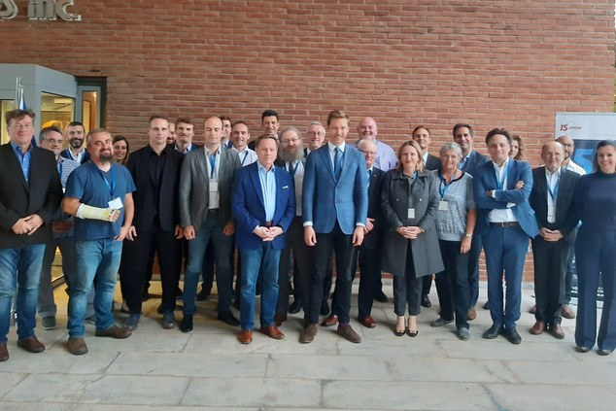

Members of the Advisory Group with ENISA Executive Director, Juhan Lepassaar and Head of Core Operations, Steve Purser

Tagged with

* [Permanent Stakeholder Group (PSG)](https://www.enisa.europa.eu/search?Subject%3Alist=Permanent%20Stakeholder%20Group%20%28PSG%29)
* [Advisory Group](https://www.enisa.europa.eu/search?Subject%3Alist=Advisory%20Group)
* [Work Programme](https://www.enisa.europa.eu/search?Subject%3Alist=Work%20Programme)

On 12 and 13 November 2019, the **Advisory Group (AG)** of the European Union Agency for Cybersecurity met in Athens, Greece to provide advice on the content of the ENISA Work Programme 2021.

Different sessions looked at the areas defined in the[Cybersecurity Act](https://www.enisa.europa.eu/news/enisa-news/enisa-news/the-european-union-agency-for-cybersecurity-a-new-chapter-for-enisa) and explored key ideas from a variety of perspectives including the viewpoints of industry, academia, relevant EU agencies and bodies and consumer protection specialists.

The Advisory Group is a statutory body of ENISA, formerly named the**Permanent Stakeholder Group**. Meetings of the Advisory Group are an important part of the Agency’s commitment to a stakeholder-driven approach to EU cybersecurity and help ensure that a wide range of opinions are taken into account when creating future work plans.

The current AG is approaching the end of its mandate and a new call for expression of interest for the selection of the new AG members will be published soon on our website.